ASSIGNMENT TASK 5
5. Number System Conversion and Arithmetic
Solve the following problems and present your solutions neatly in a Word document:
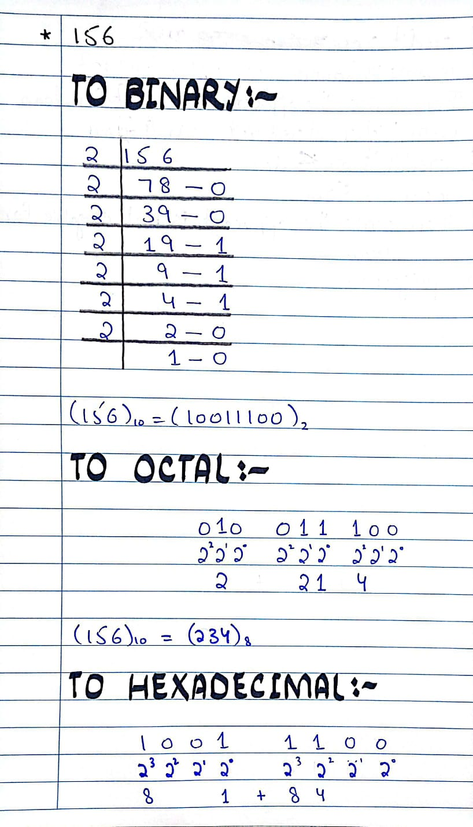
• Convert the following numbers n decimal to binary, octal, and hexadecimal: 156, 1024, 255.
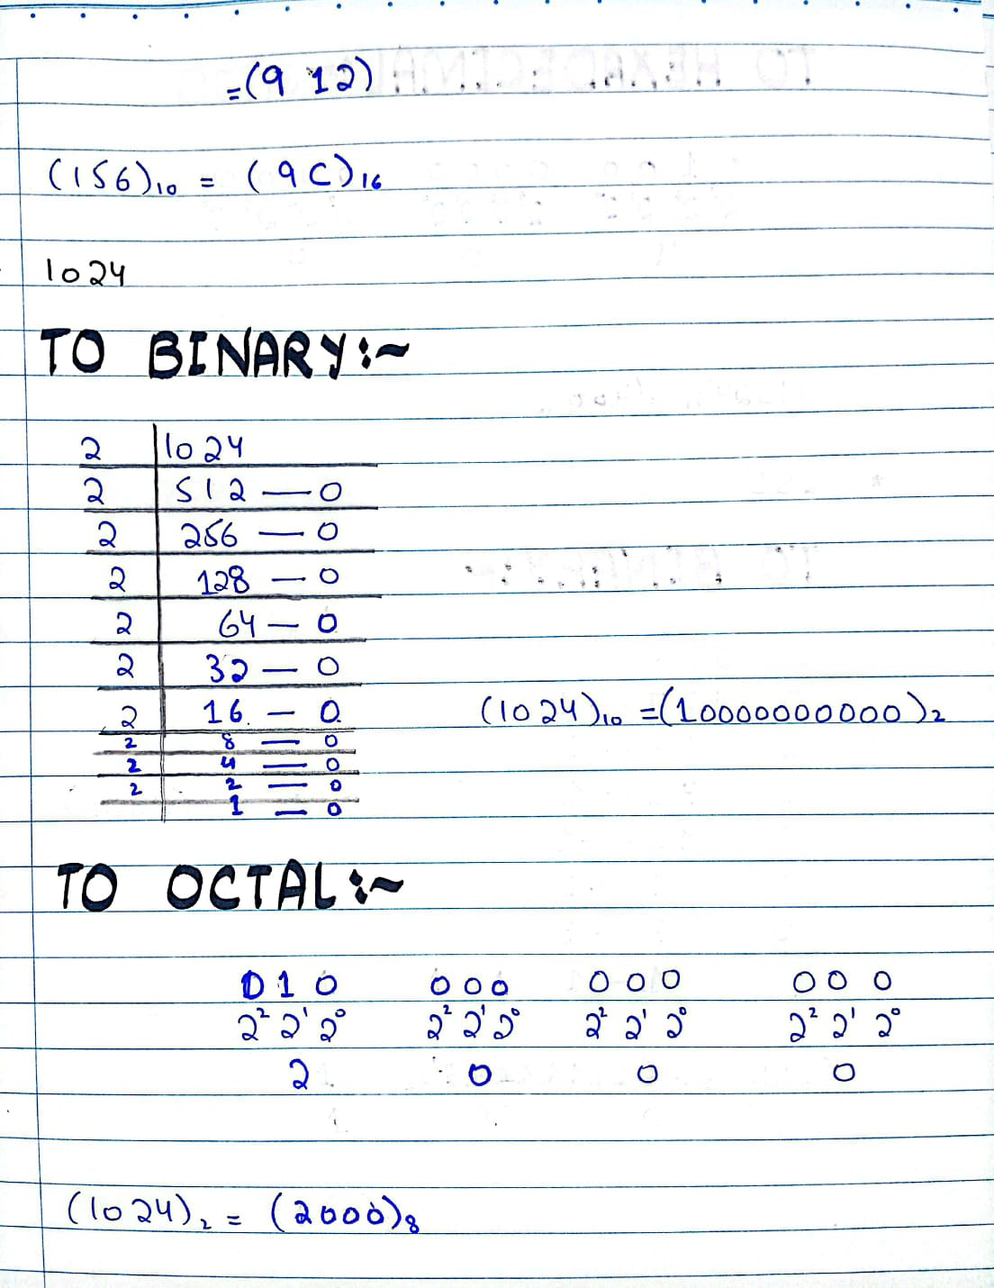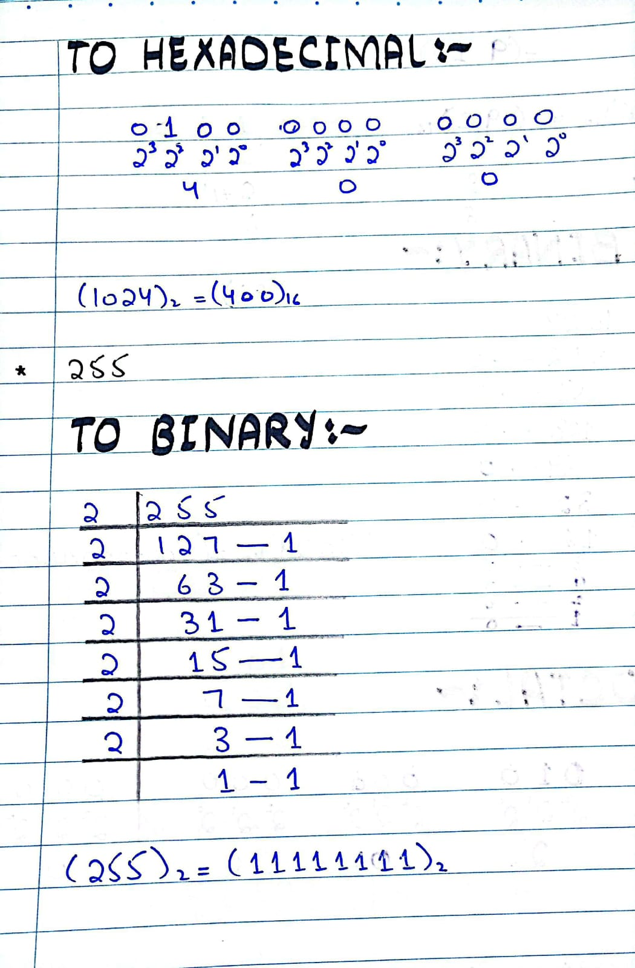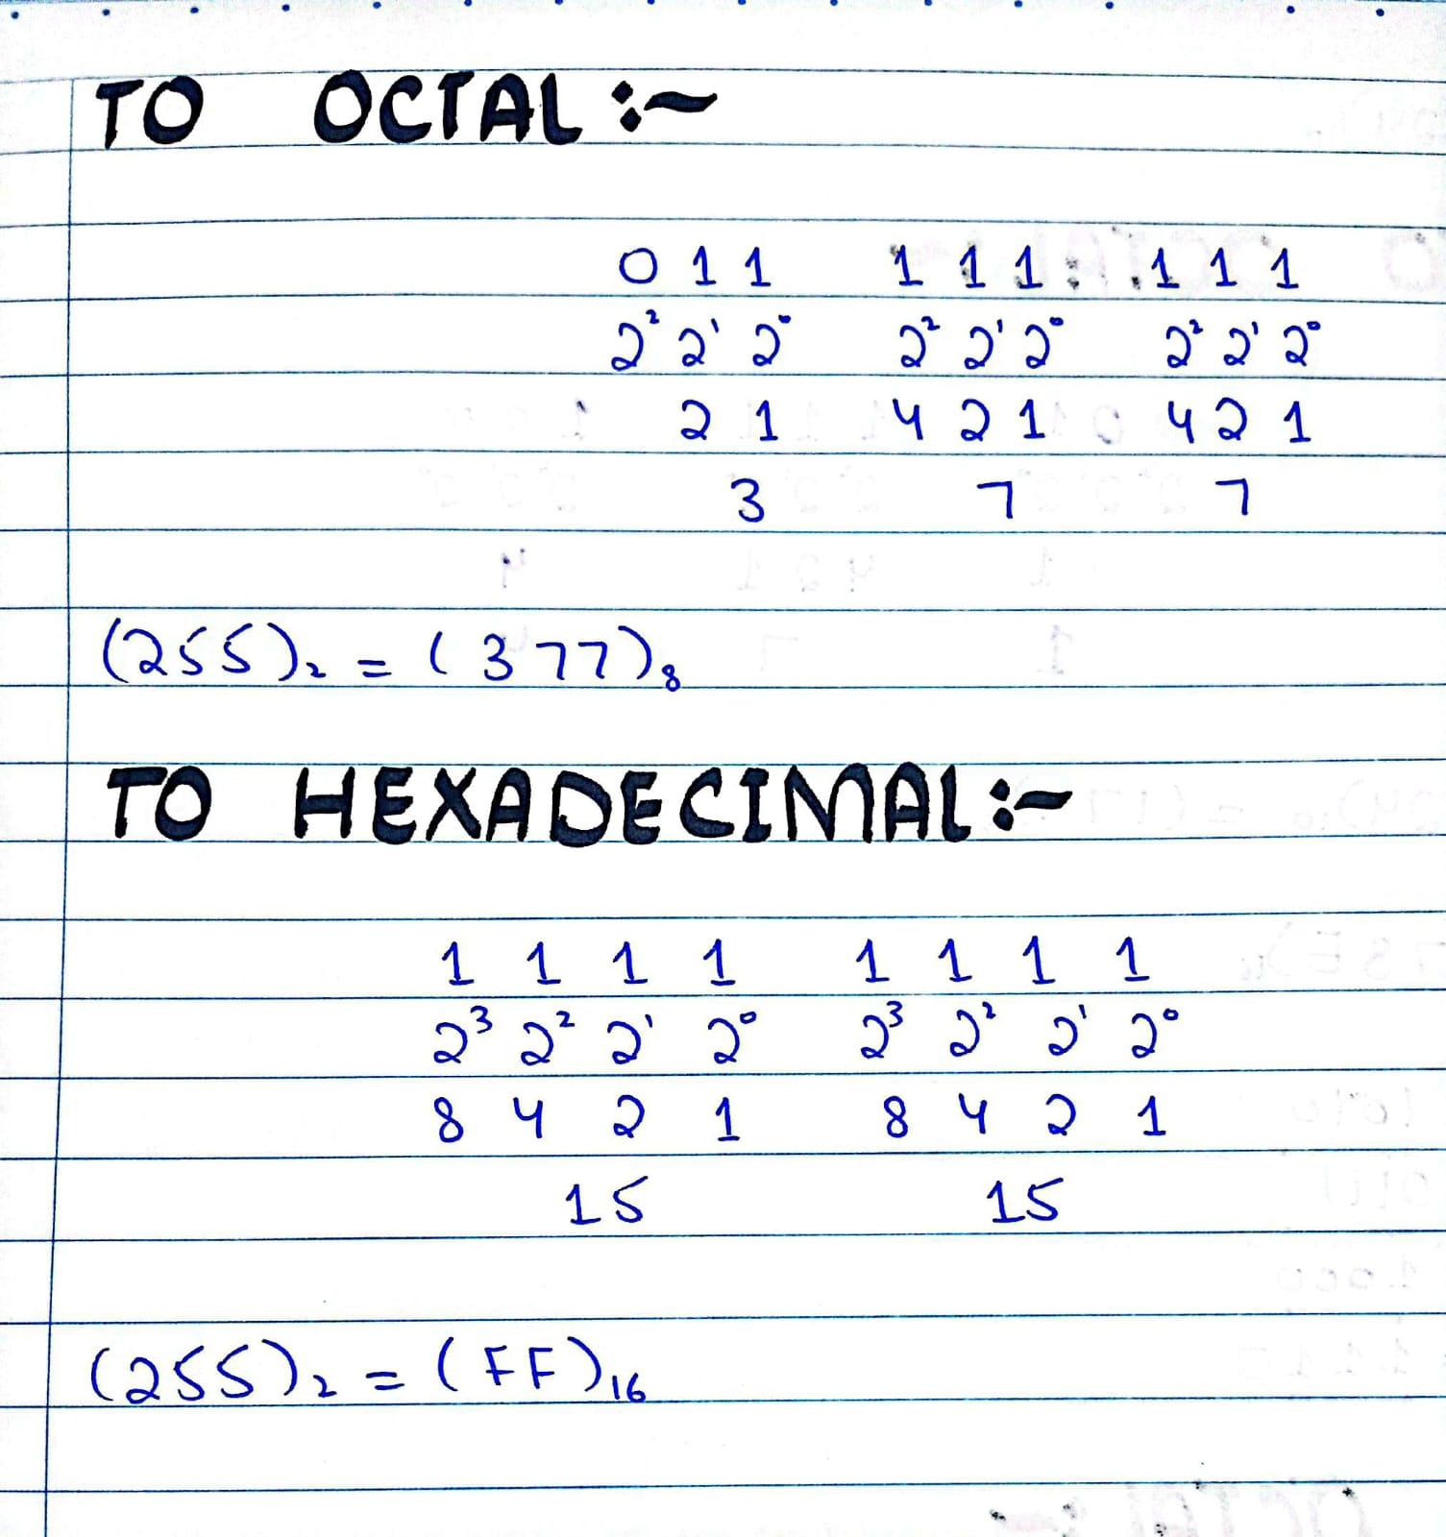

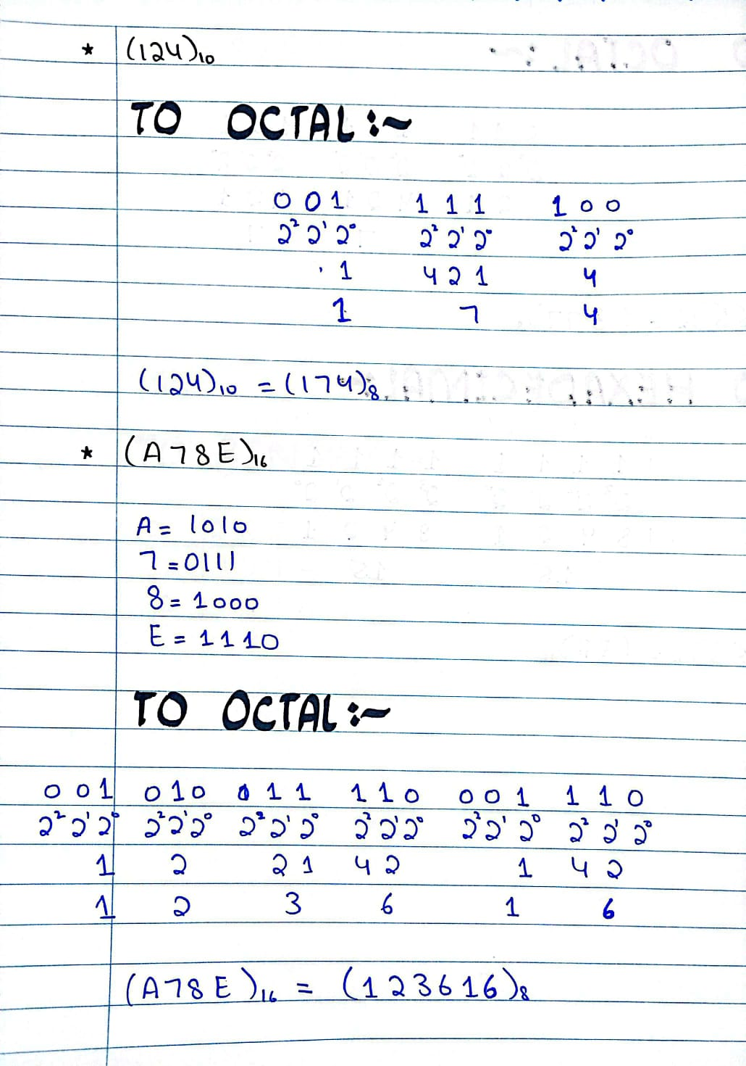
• Convert the following into Octal (124)10 , (A78E)16

• Convert the following into Hexadecimal (784)10 ,
(372)8.
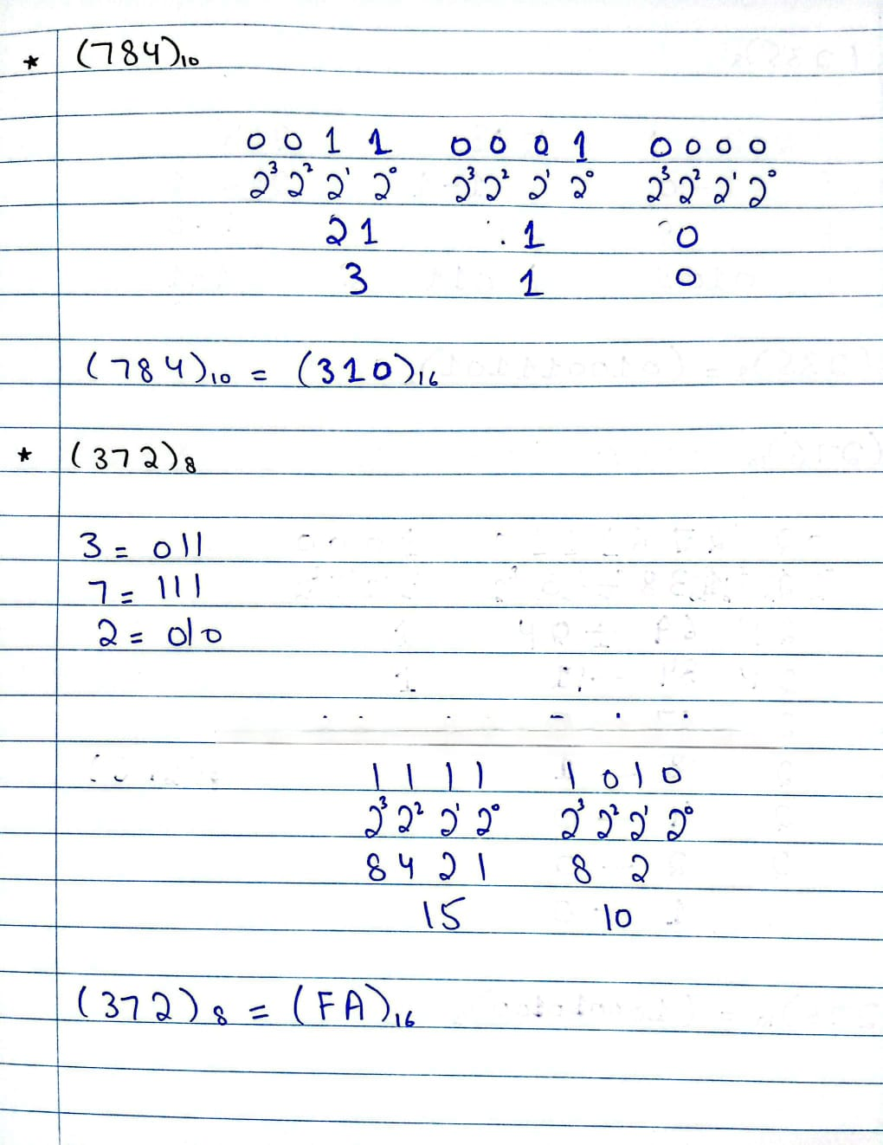
• Convert the following into Binary (235)8 ,(276)10 ,
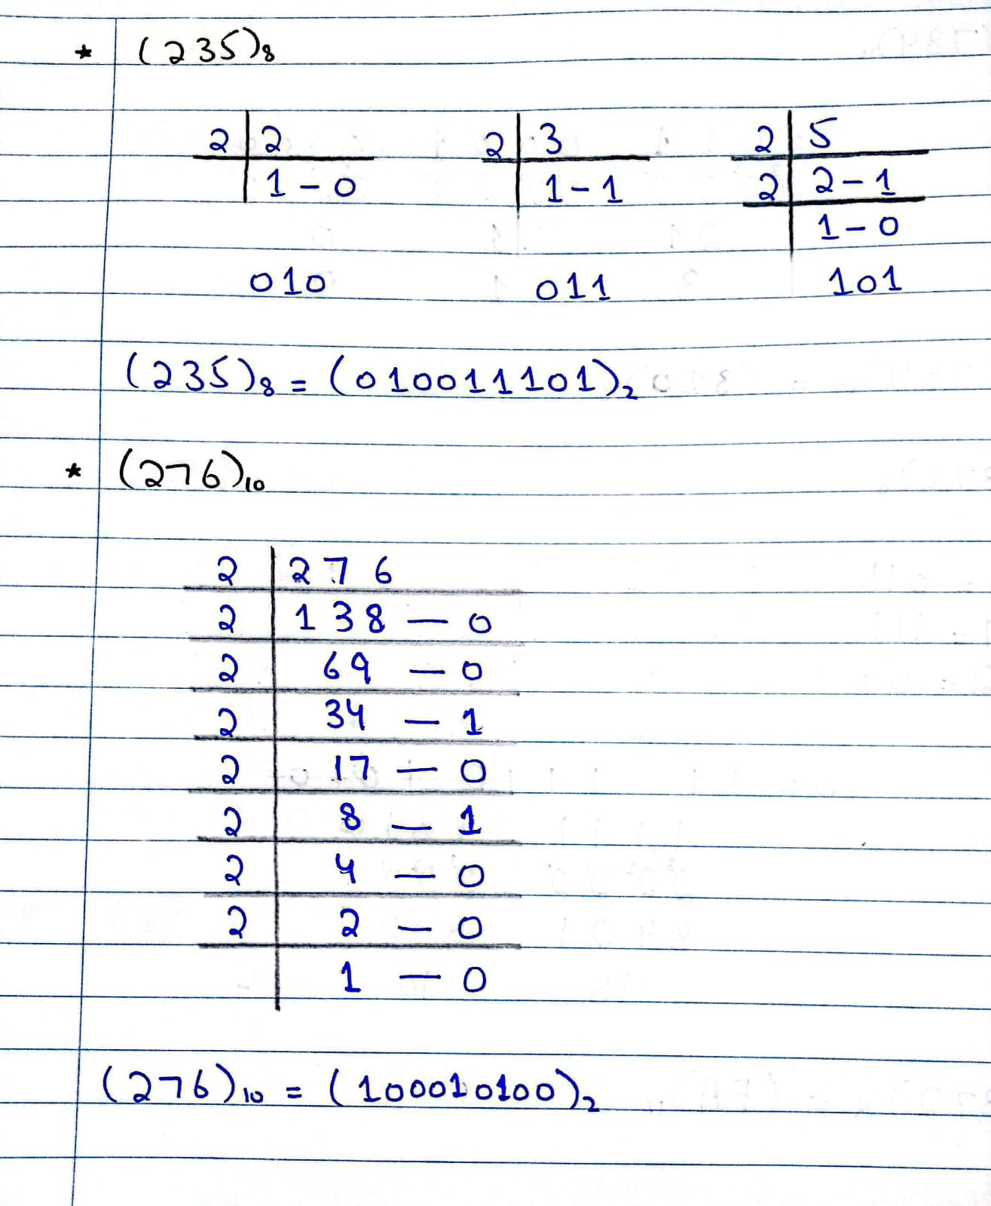
(C13E)16 .
